

Instructor: Dr. G.E. Antoniou

October 3, 2018

Day

Homework # 2

Dos Santos Ferreira, Joao Paulo

CSIT 230_02 – Computer Systems

Department of CSIT

# Problem 1:

Simplify using algebraic manipulations, the following Boolean Expressions to a minimum number of terms and factors.

**Solution:**

**Result:**

By using Boolean algebraic manipulations, the expression can be simplified to **Y**.

By using Boolean algebraic manipulations, the expression can be simplified to .

# Problem 2:

Find the complement of the following expression:

**Solution:**

To solve this problem we need to use DeMorgan’s Theorem that says

and .

**Result:**

The complement of is **.**

# Problem 3:

Using **DeMorgan’s Theorem**, express the following function …

… with only OR and complement operations.

**Solution:**

To solve this problem we need to use the property and DeMorgan’s Theorem stated on the previous problem.

**Result:**

By using the DeMorgan’s Theorem can also be represented as **.**

# Problem 4:

Simplify the following expression by means of a three-variable **K-Map**.

**Solution:**

:

|  |  |  |
| --- | --- | --- |
| **Z**  **XY** | 0 | 1 |
| 00 | 1 |  |
| 01 | 1 |  |
| 11 | 1 | 1 |
| 10 |  |  |

**Result:**

From the K-Map can be simplified to by using 2 pair loops.

# Problem 5:

Simplify the following expressions by means of a four-variable **K-Map**.

**Solution:**

1. :

|  |  |  |  |  |
| --- | --- | --- | --- | --- |
| **CD**  **AB** | 00 | 01 | 11 | 10 |
| 00 |  | 1 | 1 | 1 |
| 01 |  | 1 | 1 |  |
| 11 |  | 1 | 1 |  |
| 10 |  | 1 | 1 | 1 |

|  |  |  |  |  |
| --- | --- | --- | --- | --- |
| **CD**  **AB** | 00 | 01 | 11 | 10 |
| 00 |  |  | 1 | 1 |
| 01 |  | 1 | 1 |  |
| 11 |  | 1 | 1 | 1 |
| 10 |  |  | 1 | 1 |

**Result:**

From the K-Maps can be simplified to by using one octal and one quad loop.

And can be simplified to by using 3 quad loops.

# Problem 6:

Propose and solve your own Boolean expression problem-A.

**Problem A** - Simplify the following expression by using algebraic manipulations. Use a K-Map to confirm your answer is correct.

**Solution:**

Using algebraic manipulations:

Using a K-Map:

|  |  |  |  |  |
| --- | --- | --- | --- | --- |
| **CD**  **AB** | 00 | 01 | 11 | 10 |
| 00 |  | 1 | 1 |  |
| 01 |  |  |  |  |
| 11 |  |  | 1 | 1 |
| 10 |  | 1 | 1 | 1 |

**Result:**

By using K-Maps or algebraic manipulations the simplified form of

is .

# Problem 7:

Heart-Rate Monitor

A heart rate monitor measures an individuals heart rate and blood pressure. Both sensors output zero (0) if they are within safety range. An alarm will sound if either sensor indicates an unsafe condition is present.

Set–up the appropriate truth table, simplify using K-maps. Implement, using LogiSim, the simplified logic circuit with optimal number of logic gates.

**Solution:**

There are two inputs for this problem the heart rate (H) and blood pressure (B). Both can either output 0 or 1, with 0 being when they are within safety range. Let’s consider the output of the monitor device (M) to sound the alarm if M ever obtains the value 1.

|  |  |  |
| --- | --- | --- |
| **B** | **H** | **M** |
| 0 | 0 | 0 |
| 0 | 1 | 1 |
| 1 | 0 | 1 |
| 1 | 1 | 1 |

M can be written as:

Simplifying M using K-Maps we have:

|  |  |  |
| --- | --- | --- |
| **H**  **B** | 0 | 1 |
| 0 |  | 1 |
| 1 | 1 | 1 |

The implement version of M in LogiSim is:

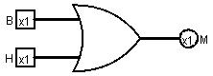

# Problem 8:

Hurricane Detector

Three LEDs (one red, one green, one blue) turn on when a number 0-7 is passed through. Red turns on with even numbers, green turns on with odd numbers, blue turns on with multiples of 3. Zero means they are all off, seven means they are all on.

Set–up the appropriate truth table, simplify using K-maps. Implement, using LogiSim, the simplified logic circuit with optimal number of logic gates.

**Solution:**

There is one input which is a number from 0-7. However, to be able to use K-Maps we would need to use binary values to represent the input, therefore we will be using 3 inputs (A, B, C) to represent a number from 0 to 7 in binary.

There are three outputs for this problem, a green (G), blue (B) and Red (R) light. They should turn on when the value 1 is passed to them. Therefore, we have the truth table:

|  |  |  |  |  |  |  |
| --- | --- | --- | --- | --- | --- | --- |
| **Decimal** | **A** | **B** | **C** | **B** | **G** | **R** |
| 0 | 0 | 0 | 0 | 0 | 0 | 0 |
| 1 | 0 | 0 | 1 | 0 | 1 | 0 |
| 2 | 0 | 1 | 0 | 0 | 0 | 1 |
| 3 | 0 | 1 | 1 | 1 | 1 | 0 |
| 4 | 1 | 0 | 0 | 0 | 0 | 1 |
| 5 | 1 | 0 | 1 | 0 | 1 | 0 |
| 6 | 1 | 1 | 0 | 1 | 0 | 1 |
| 7 | 1 | 1 | 1 | 1 | 1 | 1 |

From the truth table we have the K-Maps for each output:

B:

|  |  |  |
| --- | --- | --- |
| **C**  **AB** | 0 | 1 |
| 00 |  |  |
| 01 |  | 1 |
| 11 | 1 | 1 |
| 10 |  |  |

G:

|  |  |  |
| --- | --- | --- |
| **C**  **AB** | 0 | 1 |
| 00 |  | 1 |
| 01 |  | 1 |
| 11 |  | 1 |
| 10 |  | 1 |

R:

|  |  |  |
| --- | --- | --- |
| **C**  **AB** | 0 | 1 |
| 00 |  |  |
| 01 | 1 |  |
| 11 | 1 | 1 |
| 10 | 1 |  |

The implemented version of M in LogiSim is:

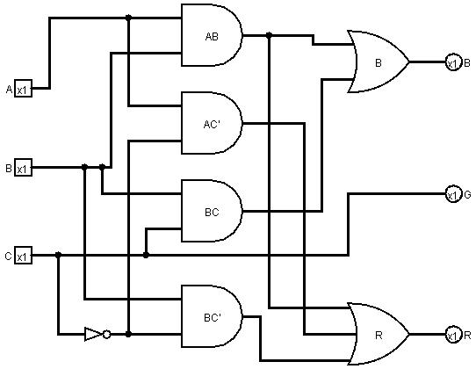

# Problem 9:

Student Grading

A teacher is grading the students in 4 subjects (Math, Spelling, English, and History) to see whether or not they will graduate. If a student passes Math and Spelling, they will graduate. If a student passes either English or History, they will graduate. All other students will not graduate.

Set–up the appropriate truth table, simplify using K-maps. Implement, using LogiSim, the simplified logic circuit with optimal number of logic gates.

**Solution:**

There are four inputs in this problem, whether or not a student passed in each of the four subjects, Math (M), Spelling (S), English (E) and History (H). A student will graduate (Output G) if he either pass on both Math **AND** Spelling **OR** if he passes either English **OR** History.

The truth table for the problem should look as followed:

|  |  |  |  |  |  |  |
| --- | --- | --- | --- | --- | --- | --- |
| **M** | **S** | **E** | **H** | **M•S** | **E+H** | **G** |
| 0 | 0 | 0 | 0 | 0 | 0 | 0 |
| 0 | 0 | 0 | 1 | 0 | 1 | 1 |
| 0 | 0 | 1 | 0 | 0 | 1 | 1 |
| 0 | 0 | 1 | 1 | 0 | 1 | 1 |
| 0 | 1 | 0 | 0 | 0 | 0 | 0 |
| 0 | 1 | 0 | 1 | 0 | 1 | 1 |
| 0 | 1 | 1 | 0 | 0 | 1 | 1 |
| 0 | 1 | 1 | 1 | 0 | 1 | 1 |
| 1 | 0 | 0 | 0 | 0 | 0 | 0 |
| 1 | 0 | 0 | 1 | 0 | 1 | 1 |
| 1 | 0 | 1 | 0 | 0 | 1 | 1 |
| 1 | 0 | 1 | 1 | 0 | 1 | 1 |
| 1 | 1 | 0 | 0 | 1 | 1 | 1 |
| 1 | 1 | 0 | 1 | 1 | 1 | 1 |
| 1 | 1 | 1 | 0 | 1 | 1 | 1 |
| 1 | 1 | 1 | 1 | 1 | 1 | 1 |

From the truth table we have the K-Map:

G:

|  |  |  |  |  |
| --- | --- | --- | --- | --- |
| **EH**  **MS** | 00 | 01 | 11 | 10 |
| 00 |  | 1 | 1 | 1 |
| 01 |  | 1 | 1 | 1 |
| 11 | 1 | 1 | 1 | 1 |
| 10 |  | 1 | 1 | 1 |

E+H+MS

Since the expression derived from the K-Map is the same as the one from the problem, that means that the expression was already simplified.

The implemented version of G in LogiSim is:

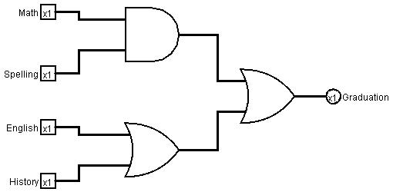

# Problem 10:

Propose and solve your own digital design problem–B

**Problem-B:**

A refrigerator lets the user know whether their food is still good to be consumed by checking when it was initially put inside of it, and whether the food was hot or cold the first time it was stored. The food is considered bad for consume if it has been stored for 3 days or more when the food was initially cold, or if it has been stored for 2 days or more when the food was hot. The day the food was initially store is considered as day 0.

**Solution:**

There is a total of 2 inputs for this problem, the initial temperate (Z) which we will consider as 0 being cold and 1 being hot, and how many days have passed since the food was initially stored, which we will treat as 2 binary inputs (X and Y) to represent the days from 0-3, for a total of 3 inputs

The output should be whether the food is good for consume or not (C), for 0 being good for consume and 1 the opposite.

|  |  |  |  |
| --- | --- | --- | --- |
| **X** | **Y** | **Z** | **C** |
| 0 | 0 | 0 | 0 |
| 0 | 0 | 1 | 0 |
| 0 | 1 | 0 | 0 |
| 0 | 1 | 1 | 0 |
| 1 | 0 | 0 | 0 |
| 1 | 0 | 1 | 1 |
| 1 | 1 | 0 | 1 |
| 1 | 1 | 1 | 1 |

From the truth table we have the K-Maps for the output C:

C:

|  |  |  |
| --- | --- | --- |
| **Z**  **XY** | 0 | 1 |
| 00 |  |  |
| 01 |  |  |
| 11 | 1 | 1 |
| 10 |  | 1 |

The implemented version of this circuit in LogiSim is:

